Manuscript Title
H. Yupi¹, W. A. N. Cruise^{2,*} and R. K. Graacht²
¹Smart Manufacturing Research Institute, Universiti Teknologi MARA, Shah Alam 40450 Selangor, Malaysia.
²School of Engineering, Universiti Teknologi MARA, Shah Alam 40450 Selangor, Malaysia.
*corresponding author: cruise8@uitm.edu.my

ABSTRACT
The abstract should be written in a single paragraph using the Normal style with Times New Roman font, size 10. The maximum nymber of words for the abstract is 300 words. A good abstract provides the readers a condensed information of the work presented in the manuscript. It should stress on the important points of each section with a flow similar to the structure of the manuscript. Most importantly, clearly highlight the problems, the objectives and the approach taken by the authors, as well as the significance of the information within the manuscript for academic or real-world engineering practices.
Keywords: provide a maximum of 5 keywords; separated by semi-colon.
Nomenclature (Greek symbols towards the end)
A_{s} | surface area of the TEG (m²)
D_{h} | nozzle hub diameter (mm)
R_{L} | external circuit resistance (Ω)
R_{TEG} | internal thermal resistance of the TEG (Ω)
α | Seebeck coefficient (0.0438 V/K)
Ɵ_{m} | vane angle (º)
∆T_{TEG} | temperature difference of the TEG surfaces (ºC)
Abbreviations

CHP | combined heat and power
MPP | maximum power point (W)

1.0 Introduction (SECTION HEADING)
The main heading of each section should be written in capital letters and numbered using Arial Narrow font size 11. Apply Sentence case for sub-section headings with structured section numberings (ie. 1.1 or 1.1.1) using Arial Narrow font size 11.
The maximum number of page is limited to 15 pages. The start of each paragraph is to be indented by 5 mm as in the template. All text should use Times New Roman with a font size of 10. Leave a blank space between the headings and the first line of text. There is no need for blank space between paragraphs.
A good introduction attempts to provide a storyline that connects all the components of the work together using the title of the manuscript as a guideline for continuity and connection between the components. Authors are encouraged to provide literatures that justifies the issues or problems addressed by the manuscript as well as providing proof that the proposed approach taken by the authors are scientifically and mathematically correct.
Citations should use the numbering format in brackets, ie. [1], [1-2] or [1] and [3]. A minimum of 30% of the references should be less than 5 years. Bulk referencing, ie. [1-5], is considered academically unethical.
The introduction section should not just list literatures without purpose or use non-related literature sources. Critical but brief statements on the significance of each literature individually or in connection to one another is necessary. Authors are adviced to respect the work of other researchers and cite them in context with the issue that is being discussed.
The introduction section should end with an executive summary of the work presented by the authors in the manuscript. The last or last two paragraphs of the introduction should systematically state the problem statement, the proposed solution or approach, the objectives, scope and limitations, as well as the signficance of the work. Novelties and research gaps should be clearly stated, but the literature to support these statements should be readily covered in other parts of the introduction section.
Authors are adviced to limit the number of words in the manuscript (excluding acknowledgement and references) to 8000 words as practiced by prominent journals.

2.0 METHODOLOGY

2.1 Structure of the manuscript
Reporting a design or simulation work requires a suitable structure to provide the readers with the necessary information about the considered factors, flow of the approach and relevancy of each procedure. Authors are adviced to plan a structure where the issues of design problems and specifications, conceived concepts, scientific and mathematical approaches, modelling framework and analyzed parameters are systematically provided and clearly justified. Apply Tables and Figures appropriately to assist the explanation.
For simulation work using numerical modelling, ensure that information on the software, model, solver, mesh schemes, initial and boundary conditions, iteration criteria and post-simulation analysis are adequately provided. Attempt to explain and justify the approach at all levels, either by using standards, references, fundamental sciences, technical judgement or showing proof-by-analysis.
Authors are also encouraged to accompany the text explanation with suitable flowcharts as well as CAD and mesh models.

2.2 Originality, Tables, Figures, Equations and Units
Upon acceptance for publication, the authors will be required to declare that all the work presented in the manuscript is original unless stated. Therefore, authors need to provide proof of publication consent to use figure(s) or table(s) derived from another publications. All figures, diagrams and tables should be referred to in the text, such as “as shown in Figure 1…” and “refer Table 1 for…”.
Position a Table immediately after it is mentioned in the text. Leave one blank line after the end of a paragraph before inserting a Table. Also, leave one blank line after a Table before starting a new paragraph. The format shown in Table X can be used directly by the authors or adjusted as needed. The title of the Table should be numbered using Arabic numerals (1, 2…) and centred above the Table with captions using Times New Roman size 10. There is no need to leave one blank line after the title. Texts within a Table should also use Times New Roman with a size range between 8 to 10 as deemed suitable (smaller font sizes for compact Tables). Adjust the sizing of the Table and text positioning so that it is compact and professionally neat. There is no limit to the number of Tables in the manuscript.

Table 1: Table caption
Column number 1 | Column number 2 | Column number 3
Parameter 1 (N) | 12.3 | 1.5
Parameter 2 (kg) | 34.50 | 12.00
Parameter 3 (mm) | 25 | 9

Position a Figure immediately after it is mentioned in the text. Authors may write”Fig. 1” or “Figs. 1 and 2” in the text to refer to specific figures. However, the figure title should be spelled in full (Figure 1) such as shown in Fig. 1. Leave one blank line after the end of a paragraph before inserting a Figure. Also, leave one blank line after a Figure before starting a new paragraph. The title of the Figure should be numbered using Arabic numerals (1, 2…) and centred below the Figure with captions using Times New Roman size 10. Adjust the sizing of the Figures so that the illustration and embedded texts are clear to the readers (embedded text sizes appears at approximately font size 8). The authors are adviced to limit the number of Figures to 12 figures as practiced in prominent journals. Ocmbination of diagrams for a single Figure is allowed as in Fig. 2, but the the diagrams should be grouped based on similar domains. Figure outlines are optional (use black color for outlines).

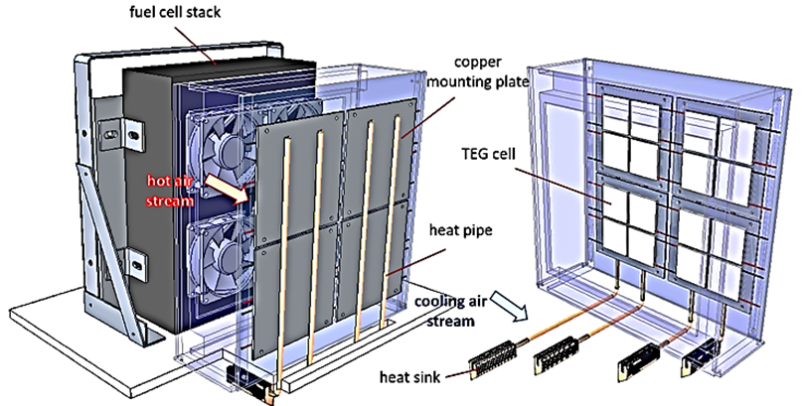

Figure 1. Concept design of the system. Embedded text size should be readable and not be relatively larger than the title text

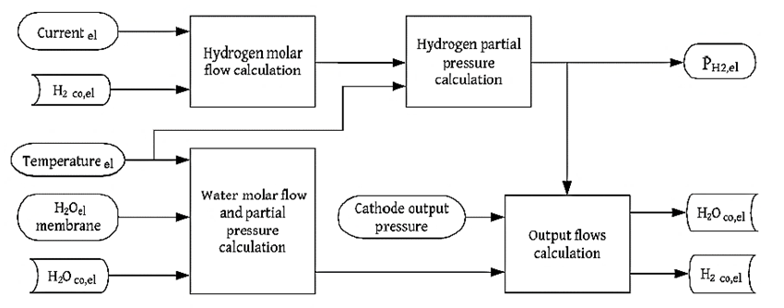
(a)

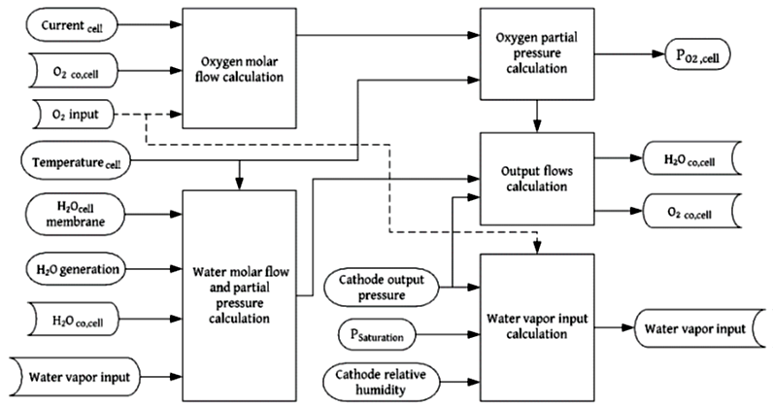
(b)

Figure 2. Mapping of the PEM electrolyzer mass balance model for (a) cathode side, and (b) anode side

An equation should be proceeded and followed by one blank line, and should be referred to, in the text, in the form Equation (1). All symbols should be explained within the manuscript and in italic. To preserve the form and font sizes of the parameters in the equations, it is advisable to insert the equation in a three-column table. Position the Equation, the unit and the equation number to Align Left. The unit of the Equation should be placed next to the Equation. As an example:
The average coolant temperature, T_{avg}, can be calculated from Equation (1),

$$T_{avg}=\frac{T_{1}+T_{2}}{2}$$ | (ºC) | (1)

where T₁ and T₂ are the measured surface temperatures using the k-type thermocouple probes.

The International System of Units (SI) is to be used; other units can be used only after SI indications and should be added in parenthesis.

3.0 Results AND DISCUSSION
In the first paragraph, it is advisable to provide a brief on the flow of the analysis presented in the section relative to the the questions or objectives addressed by the work.
Presentation of graphs or diagrams should be of high quality and consistent (ie. layout, font type and size, tickmarks, line types, symbols etc.).

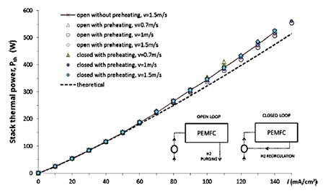 | 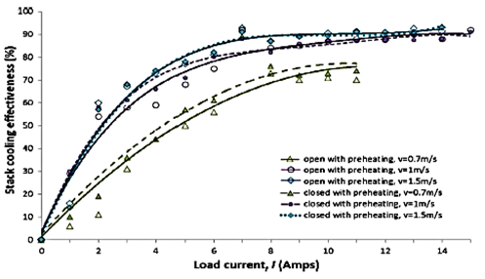

-Example of two graphs for different analysis with consistent presentation styles-

A good discussion of results should have these elements:
- Apply standard or accepted methods for graphs, diagrams and analysis as practiced by the area of study,
- Presented with a structured continuity and focusing on answering the research questions,
- Section the results or analysis systematically to build the argument or proof for the targeted outcome,
- Discuss the results in detail and relate to the fundamentals of science and mathematics, or compare with existing results from literature, and
- Provide conclusive statements about the analyzed parameters.

4.0 Conclusion
The aim of the conclusion is to systematically relate all the important aspects and information within the manuscript towards achieving the targeted objectives. Clearly state the main findings as well as its limitations. A good way to close the study is by positioning the results to the existing body of knowledge or by suggesting possible opportunities derived from the findings, etiher for academic studies or for real-world practices.The conclusion should not be more than one page in length.

Acknowledgement
This section should clearly state the funding grants and agencies (if applicable) as well as acknowledging individuals (non-authors) or institutions that have contributed to the work.

References
Journal references should be according to IEEE format, which include all the surnames of authors and their initials, year of publication in parenthesis, full paper title within quotes, full or abbreviated title of the journal, volume number, issue number and pages. Examples below show the format for references including books and proceedings. The DOI of each reference is optional.

[1] J. B. Caccese et al., “Head and neck size and neck strength predict linear and rotational acceleration during purposeful soccer heading,” Sport. Biomech., vol. 17, no. 4, pp. 462–476, 2018, doi: 10.1080/14763141.2017.1360385.
[2] M. S. Sulaiman, W.A.N.W. Mohamed and B. Singh, “Experimental and theoretical study of thermoelectric generator waste heat recovery model for an ultra-low temperature PEM fuel cell powered vehicle,” Energy, vol. 179, pp. 628-646, 2019.
[3] M. K. Ghosh and A. Nagraj, “Turbulence flow in bearings,” Proceedings of the Institution of Mechanical Engineers, vol. 218, no. 1, pp. 61 – 64, 2004.
[4] P. N. Rao, “Manufacturing Technology Foundry”, in Forming and Welding, 2nd ed. McGraw Hill, Singapore, 2000, pp. 53 – 68.
[5] D. Sarunyagate, Ed., Lasers. New York: McGraw-Hill, 1996.
[6] Hutchinson, F. David and M. Ahmed, U.S. Patent No. 6 912 127, 28 June 2005.
[7] J. Riley, "Call for new look at skilled migrants," The Australian, p. 35, May 31, 2005. [Online]. Available: Factiva, http://global.factiva.com. [Accessed May 31, 2005].

